**PRACTICAL - 3**

Creating a resource

Deploying OpenAI

Setting IAM

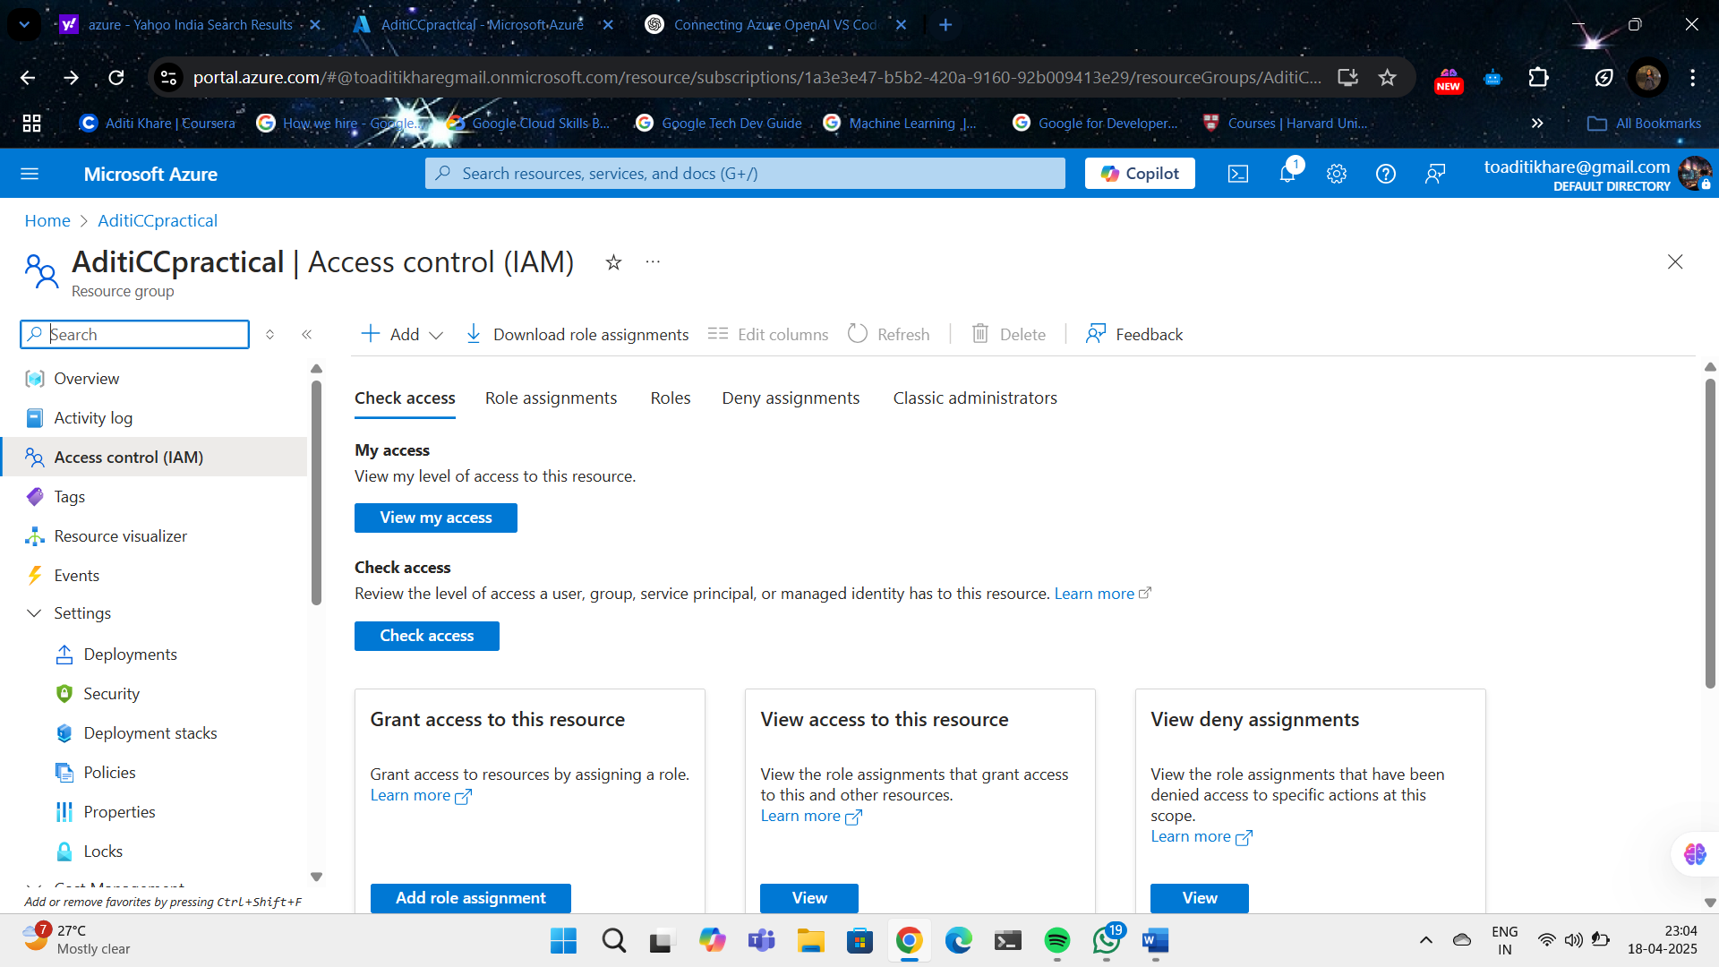

Opening Azure AI Foundary

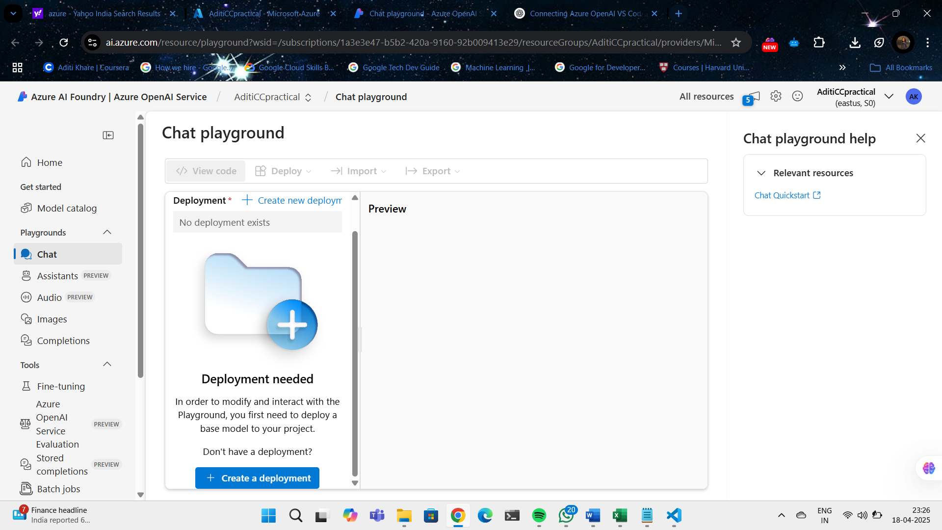

Selecting a model

Deploying the model

Retrieving model API Key and Endpoints URI

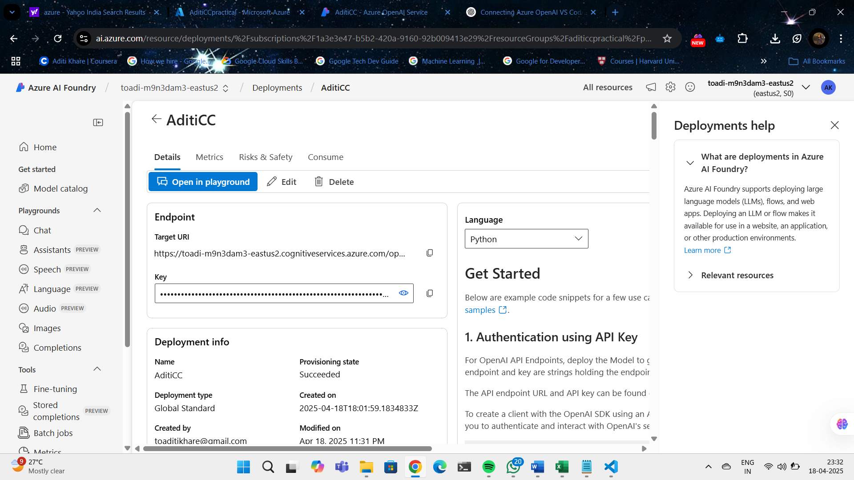

CODE

from openai import AzureOpenAI

# Correct Azure OpenAI resource details

client = AzureOpenAI(

    api_key="8MJOSeZvDynIRnCgf2qNNbTGOZvOs5c2Apvhr1XpiwDdXkBj7ghZJQQJ99BDACHYHv6XJ3w3AAAAACOGRM2I",  # Azure OpenAI Key

    azure_endpoint="https://toadi-m9n3dam3-eastus2.cognitiveservices.azure.com/openai/deployments/AditiCC/chat/completions?api-version=2025-01-01-preview",  # Correct endpoint format

    api_version="2024-12-01-preview"

)

# Chat completion call

response = client.chat.completions.create(

    model="AditiCC",  # Deployment name, NOT model name

    messages=[

        {"role": "system", "content": "You are a helpful assistant."},

        {"role": "user", "content": "I am going to Paris, what should I see?"}

    ],

    max_tokens=4096,

    temperature=1.0,

    top_p=1.0

)

# Print the assistant's reply

print(response.choices[0].message.content)

OUTPUT

